Q1. “ggga d” is my identity, and that identity is the answer

Ans - Shegaon

Q2. The person who made us is the answer.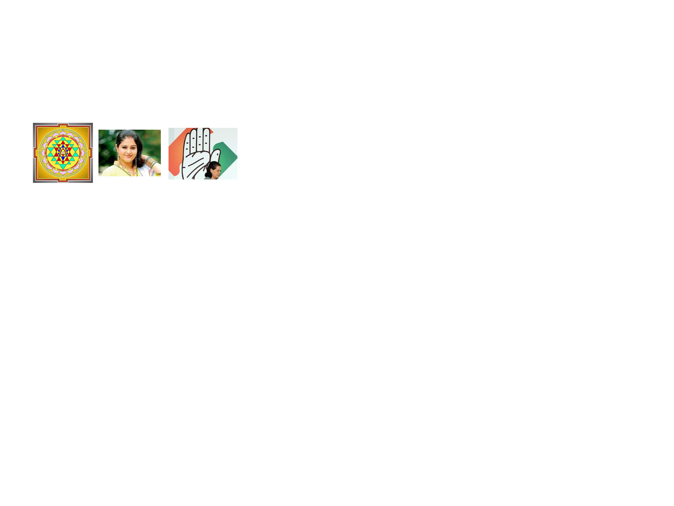

Ans - Maharaja Jai Singh II

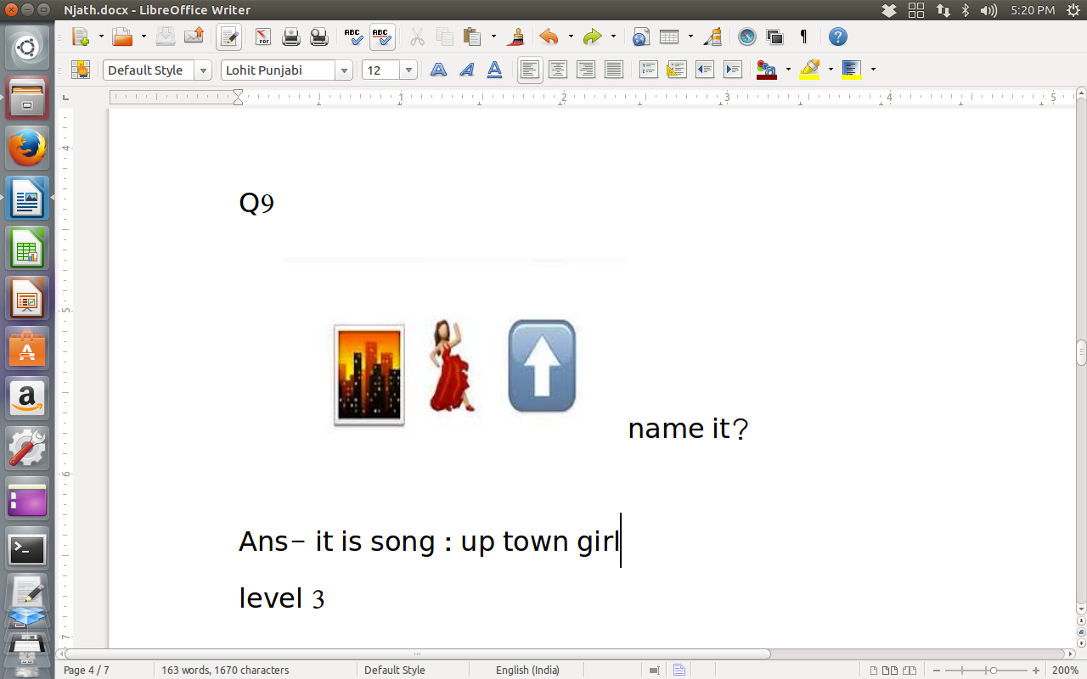

Q4.

Hint: It is a song

Ans - Up town girl

Q5. Which movie is related to both images?

Ans - Khiladi 786

Q6. Find the common link between images.

Ans - Cupid

Q7. I am full of fun.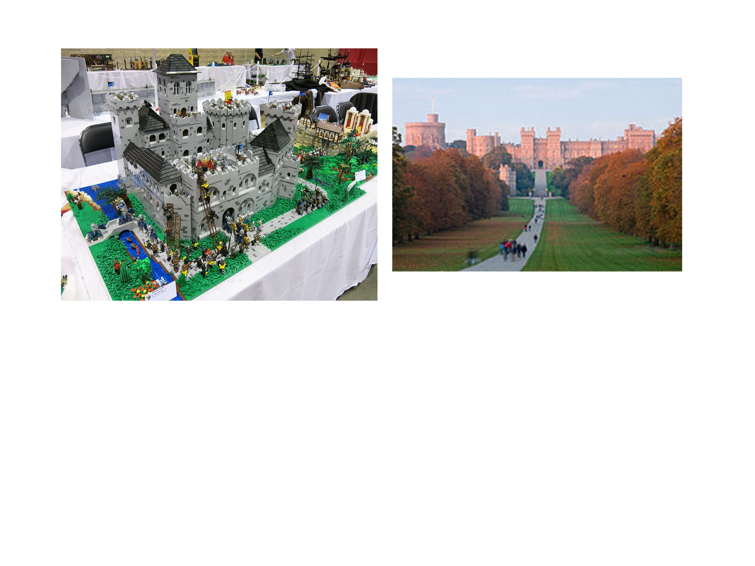

Ans - Legoland Windsor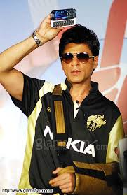

Q8.

There are many milestones in “aamwg”'s way. Identify the d'th one.

Ans – Bhopal